ES0 203A INTRODUCTION to EE 20.1.17
TUT2
Q1: A single phase load is being supplied from a 230V 50 Hz source. It draws 10KW at 0.8pf lagging (p.f is a common abbreviation for power factor).It is desired to connect a capacitor in parallel to the load to improve the p.f. of the source to unity. Calculate the value in microfarads and KVA rating of the capacitor.
(Ans: 7.5 KVAR)
Q2: (a) Write the loop equations for the circuit shown below.
(b) Find 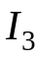 if 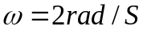

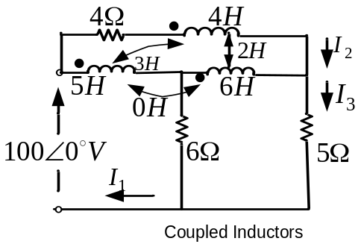

(Ans:Z*I=V, 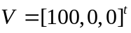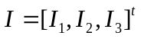written row-wise the impedance matrix is

Q3: A delta connected load has impedances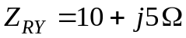,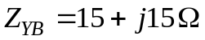,
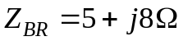, and is connected to a 400V supply of phase sequence RYB.
Calculate the readings of two wattmeters with current coils in line R and B and voltage coils connected to line Y.
(Ans: 4.8 kW, 22.3 kW)

Q4: A single phase transformer has 400 primary turns and 1000 secondary turns. The net cross sectional area of the core is 60 Cm².If the primary winding is connected to a 50 Hz supply a500 Volts; calculate the peak value of flux density in the core and the voltage induced in the secondary windings.
(Ans: 0.938Wb/m², 1250V)

Q5: Two identical 1000 turn coils X and Y lie in parallel planes such that 60% of the magnetic flux produced by one coil links the other. A current of 5A in X produces in it a flux of 0.05mWb.Calculate the self inductance of each coil and the mutual inductance
If the current in X changes from +6A to -6A in 10mS what will be the magnitude of e.m.f induced in Y?
(Ans: 7.2V)

